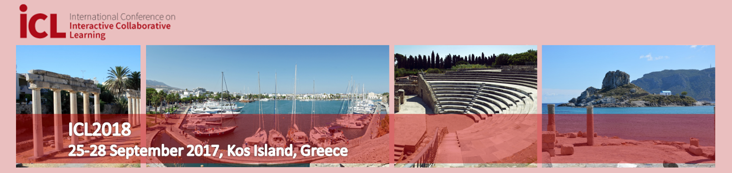

Sponsor Packages

Sponsorship benefits are offered in three levels, corresponding to:
- Platinum Sponsor Package: 6.000 €
- Gold Sponsor Package: 3.000 €
- Silver Sponsor Package: 1.000 €

Services | Silver | Gold | Platinum
Publicity in e-form (in the ICL website) | x | x | x
Company logos in the conference flyers (printed) | x | x | x
Company logos in the conference lobby and in the conference bags | x | x | x
Company logos in the technical session rooms |  | x | x
Advertising space at the exhibition hall (vertical 1,5 x 1,5 m) |  | x
Table at the exhibition hall (horizontal 1,0 x 2,0 m) |  |  | x
Conference tickets included | One | Up to three | Up to five
Advertising materials in the conference bags | x | x | x
Company logos in the social program |  |  | x
Workshop/Product presentation (60 min) |  |  | x
Talk in a plenary session (15 min) |  | x
Talk in a plenary session (30 min) |  |  | x

Publicity in e-form corresponds to logos displayed at the conference web site.

Printed publicity includes Silver posters, Gold posters and Platinum posters. The posters show the logos in different size. Printed publicity also includes conference flyers that display the sponsors’ logos, distributed in the conference lobby and in the conference bags.

Gold Sponsors can use an advertising space on the wall of the exhibition hall for information about company, products etc. Platinum Sponsors is also offered a table at the exhibition hall for product presentations, presentation of company etc.

Platinum Sponsors are invited to deliver a 30min. talk in a plenary session. Gold sponsors have 15 min. time slot in a plenary session.

Additional Advertising and Sponsorship Opportunities
We are open to advertising and sponsorship opportunities that are not listed here. Please contact the ICL Office by email at tsiatsos@csd.auth.gr & info@icl-conference.org or by phone at +30 6936 971379, if you would like to discuss alternative options.

Order of a sponsor package

Company/Institution Name
Contact Person Name
Email Address
City
Postal Code/ Zip
Country
Phone
Fax
Company URL

We order hereby the following sponsor package for the participation in the international conference ICL2018 Conference at Kos International Convention Centre, Kos Island, Greece on 26-28 September 2018:

 |  | Platinum Sponsor Package | 6.000 €
 |  | Gold Sponsor Package | 3.000 €
 |  | Silver Sponsor Package | 1.000 €

Please mark a desired sponsor package with a cross. The costs for the sponsor packages are netto prices. The value added tax of 24% is still added.
Please send a completed and signed scanned copy of this form via e-mail to Assist. Prof. Thrasyvoulos Tsiatsos (ICL2018 Conference Chair) at tsiatsos@csd.auth.gr until July 20th, 2018.

Print Contact Person Name:
Signature:
Date:

